

LEGAL OFFICE PROCEDURES
(245)

NATIONAL 2020

Part I OBJECTIVE
Written Test (40 questions @ 5 points each) ____________(200 points)
Part II PRODUCTION
Job 1 – Affidavit ____________(100 points)
Job 2 – Letter ____________(100 points)

TOTAL POINTS ____________(400 points)

Judges/Graders: Please double check and verify all scores and answer keys!

Property of Business Professionals of America.
May be reproduced only for use in a Business Professionals of America Workplace Skills Assessment Program competition.

GENERAL INSTRUCTIONS
- Answer the objective questions using the Scantron scoring sheet provided.
- Make certain this test booklet contains Job 1-2.
- Key all jobs according to the instructions given.
- Correct any obvious keyboarding errors and incorporate any editing notations.
- Correct any errors in formatting. Use formatting shown in the Style & Reference Manual.
- For any problem where you would normally key your reference initials, key your contestant number. Your name or initials should not appear on any work you submit.
- Key your contestant number and job number as the footer in the lower left-hand corner of all work submitted unless otherwise specified.

Example:
99-9999-9999
Job 1

- If you finish before the end of the testing time, notify the proctor. Time may be a factor in determining a winner when there is a tie score.
- When turning in your materials, place your scoring sheet on top of your jobs. The jobs should be arranged in numerical order. Turn in all partial jobs completed
Production Standards

0 Errors | 100 points
1 Error | 90 points
2 Errors | 70 points
3 Errors | 50 points
4+ Errors | 0 points

PART I – OBJECTIVE

SECTION 1 – LEGAL KNOWLEDGE
SECTION 2 – WORKING IN A LEGAL OFFICE

1. | a |  | 11. | a |  | 21. | d |  | 31. | c
2. | c |  | 12. | c |  | 22. | a |  | 32. | c
3. | d |  | 13. | d |  | 23. | b |  | 33. | a
4. | d |  | 14. | d |  | 24. | c |  | 34. | b
5. | b |  | 15. | b |  | 25. | b |  | 35. | a
6. | b |  | 16. | c |  | 26. | d |  | 36. | c
7. | d |  | 17. | d |  | 27. | a |  | 37. | a
8. | b |  | 18. | c |  | 28. | c |  | 38. | c
9. | a |  | 19. | c |  | 29. | b |  | 39. | c
10. | d |  | 20. | b |  | 30. | d |  | 40. | a

PART II – PRODUCTION

Your role in the production part of this test is to work for the law firm of Wooster & Hunt as a legal office assistant. You have been asked to prepare a letter for attorney Randall Nebeker:

Job 1: Letter to a client, Mr. and Mrs. Sydney Nelson, from Randall Nebeker. Sydney Nelson’s wife’s name is Maria Nelson.

Job 2: Durable Power of Attorney
Grantor: Sydney Nelson -- Granting Power of Attorney to Maria Nelson
Bank: Chicago First National Bank

Be sure to follow the contest and format guidelines in the WSAP, the BPA Style & Reference Manual, and the General Instructions provided with this event.

JOB 1
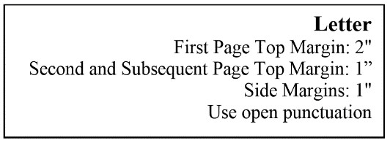
[Current date]

Mr. and Mrs. Sydney Nelson
Fourth Street Tower
Apartment B-29
Chicago, IL 60601-1234

Dear Mr. & Mrs. Nelson

Over the course of the next month we will meet and then I will prepare the documents we discussed to ensure your estate plan is set up the way you intend. My assistant Tony Trent will contact you next week to set up a time for you to come to the office and meet with me. Please plan for this meeting to take about an hour. Also plan to bring with you the following:

- The most recent LAST WILL AND TESTAMENT for each of you.

- Living wills or health care directives for each of you. If you have not completed these documents in the past, enclosed is a sample for you to review and consider.

- A list of all your assets. This may be time consuming, but it is absolutely imperative for me to get a complete picture of your estate in order to give you the best legal advice for your estate plan.

You do not need to get these items to me ahead of time, but please set up the meeting as soon as you think you will have these items pulled together. The sooner we get started, the easier it will be for us to prepare your documents and subsequently meet again to execute them before you leave for your trip abroad. If you have any questions while you are preparing to meet, please give me a call.

Sincerely

Randall Nebeker

Contestant #

Enclosure
Contestant #
Job 1
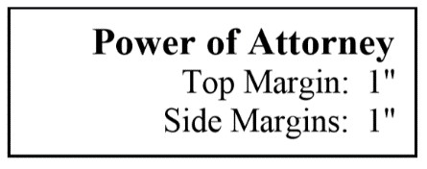
JOB 2
DURABLE POWER OF ATTORNEY (bold)
(DS)
Know All Men By These Presents: (bold) |
(DS)
That SYDNEY NELSON, Grantor, has made, constituted, and appointed, and by these presents does make, constitute, and appoint MARIA NELSON his true and lawful attorney-in-fact for him and in his name, place and stead, for the sole and singular purpose of:
executing any and all documents necessary or required to establish or create a joint account between SYDNEY NELSON and MARIA NELSON at Chicago First National Bank or any other banking or savings and loan institution, and further, MARIA NELSON is further empowered to make, do, and transact any and every kind of business of whatsoever kind and whatsoever nature on behalf of Grantor,
(DS)
giving and granting unto MARIA NELSON, said attorney-in-fact, full power and authority to do and perform all and every act and thing whatsoever requisite and necessary.
IN WITNESS WHEREOF, I have hereunto set my hand and seal this ___ day of _________________ (1½" line), 20___.
(QS)
________________________ (2” line)
Notary Public

Signed and sealed in the presence of
(QS)
_________________________ (2” line) (2” line, right aligned) _______________________ Witness
(QS)
_________________________ (2” line)
Witness
Durable Power of Attorney of Sydney Nelson
Page 1 Intitials ____________
Contestant #
Job 2

